**MAC-CPTM Situations Project**

**Situation 01: Sine 32°**

Patricia Wilson, Heather Johnson, Jeanne Shimizu, Evan McClintock,

Rose Mary Zbiek, M. Kathleen Heid, Maureen Grady, Svetlana Konnova

**Prompt**

After completing a discussion on special right triangles (30°-60°-90° and 45°-45°-90°), the teacher showed students how to calculate the sine of various angles using the calculator.

A student then asked, “How could I calculate sin (32°) if I do not have a calculator?”

**Commentary**

The set of foci provide interpretations of sine as a ratio and sine as a function, using graphical and geometric representations. The first four foci highlight  as a ratio, appealing to the law of sines, right-triangle trigonometry, and unit-circle trigonometry. The second three foci highlight as a function and use tangent and secant lines as well as polynomials to approximate.

The question of “how good” an approximation one gets using secants, tangents, or Taylor polynomials depends on the size of the *x*-interval, the order of the highest derivative, and the function(s) in question. These challenging problems are usually taken up in courses on mathematical analysis and numerical analysis.

**Mathematical Foci**

**Mathematical Focus 1**

*Ratios of lengths of sides of right triangles can be used to compute and approximate trigonometric function values.*

A ratio of measures of legs of a right triangle with an acute angle of measure *x*° can be used to *approximate* sin(*x*). Sin(*x*) can be approximated by sketching a 32°-58°-90° right triangle with a protractor or with dynamic geometry software, measuring the length of the hypotenuse and leg opposite the 32° angle, and computing the sine ratio (see Figure 1).

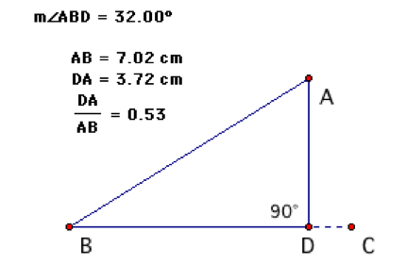

*Figure 1.* Right triangle ABD with a 32° angle.

Hence,.

**Mathematical Focus 2**

*Coordinates of points on the unit circle represent ordered pairs of the form (,) that can be used to approximate trigonometric values.*

The unit circle is the locus of all points one unit from the origin. The equation for a circle with radius 1 centered at the origin is. Consider the angle  in standard position formed by the x-axis and a ray from the origin through a point A on the unit circle. Then, and. Hence, the coordinates of A are, and another equation for a circle with radius 1 centered at the origin is.

Let A be positioned on the unit circle so that ABD has degree-measure 32° (see Figure 2). Then, the signed length of segment AD is equal to sin (32°).

The signed length of segment AD is approximately 0.53 and so, 

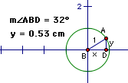

*Figure 2.* Right triangle ABD with a 32° angle on a unit circle.

**Mathematical Focus 3**

*The law of sines can be used to compute and approximate the sine function value through the measurement of geometric constructions.*

The law of sines applies to any triangle in a plane. Consider triangle ABC, with sidelengths *a*, *b*, and *c* for , , and , respectively. The law of sines states:

.

Sin() can be approximated by sketching any triangle the degree-measure of one of whose angles is  and the degree-measure of another of whose angles has a known sine value (e.g., , , , or ).

For example, a triangle can be sketched (with software such as Geometer’s Sketchpad) with mA =  and mB =  (see Figure 3). Using the measure *a* and the measure *b* (the length of the side opposite theangle), sin() can be calculated using the law of sines.



Because sin(90°) = 1, then 



*Figure 3*. Using the law of sines and sin(90°) to calculate sin(32°).

Hence, 

In another example, a triangle can be sketched (with software such as Geometer’s Sketchpad) with mA =  and mB =  (see Figure 4). Using the measure *a* and the measure *b* (the length of the side opposite the angle), sin  can be calculated using the law of sines.

By the law of sines, 

Because , then .



*Figure 4.* Using the law of sines and sin(30°) to calculate sin(32°).

Hence, 

**Mathematical Focus 4**

*A continuous function, such as*, *can be represented locally by a linear function and that linear function can be used to approximate local values of the original function.*

The function  is not a linear function; however, linear functions can be used to approximate nonlinear functions over sufficiently small intervals.

Measuring angles in radians:

is equivalent to  radians, Therefore:

is equivalent to  , or 0.5236 radians

is equivalent to  , or 0.5585 radians

is equivalent to  , or 0.7854 radians

Figure 5 shows the graph of the function  and the graph of the secant line, where the coordinates of A are  and the coordinates of B are. Because the function  is approximately linear between points A and B, the values of the points on the secant line, , provide reasonable approximations for the values of  between points A and B (see Figure 5). Because sin(x) is concave down in the interval for *x* of , the estimate for sin(32°) will be an underestimate.

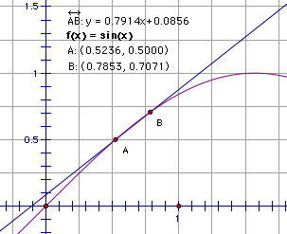

*Figure 5.* Using a secant line to estimate sin(32°).

In Figure 6, point D on secant line  with coordinates  provides a reasonable approximation for the location of point C on  with coordinates.

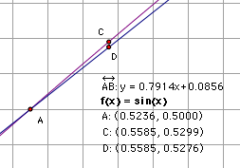

*Figure 6.* Zooming in on the estimate of sin(32°) using a secant line.

Therefore,.

An approximation for  can also be found by using the equation for secant line. Since secant line  passes through the points   (0.5236, 0.5) and(0.7854 0.7071) , its equation can be approximated as follows:



When *x* = 0.5585, *y* = 0.5276.

Therefore, sin() = 0.5276.

**Mathematical Focus 5**

*Given a differentiable function and a line tangent to the function at a point, values of the tangent line will approximate values of the function near the point of tangency.*

Because the function  is differentiable, given a point  on, the line tangent to  at  can be used to approximate  at a nearby point with *x*-coordinate *a* + *dx*. When is small, the value of the tangent line at the point with *x*-coordinate *a* + *dx* will be very close to the value of . Using radian measure, is equivalent to  , or 0.5585 radians.

Consider a geometric interpretation of differentials  and  and their relation to  and , where a tangent line is used to approximate  near a given value (see Figure 7).



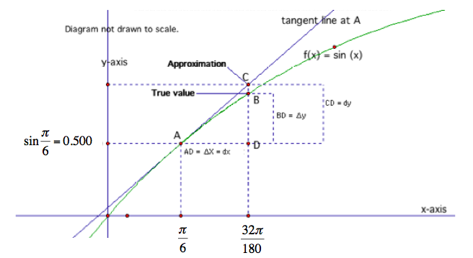

*Figure 7.* A geometric interpretation of differentials to estimate sin(32°).

Since  and,

Then,

.

**Mathematical Focus 6**

*The theory of Taylor series provides the definition of the sine function based on the foundations of the real number system, independent of any geometric considerations.*

The sine function could be defined using an infinite series. The following identity holds for all real numbers *x*, with angles measured in radians:



The sine function is closely approximated by its Taylor polynomial of degree 7 for a full cycle centered on the origin,  (see Figure 8).

 *Figure 8.* Taylor polynomial approximating the sine function.

**Postcommentary**

Although they differ in the use of ratios versus the use of lines as approximation tools, all four methods involve approximations. The ratio methods depend on a definition of the trigonometric functions and therefore are not generalizable to other types of functions, whereas the line methods depend on characteristics of continuous functions and therefore can be used for a wider range of functions.